Lab 13 task 1: Create VMFS Datastores for the ESXi Host
You set up VMFS datastores on iSCSI-based storage devices to be used as repositories by virtual machines.
1. Using the vSphere Client, log in to sa-vcsa-01.vclass.local by entering administrator@vsphere.local for the user name and VMware1! for the password.
2. From the Menu drop-down menu, select Storage.
3. Create a VMFS datastore called VMFS-2 on the specified LUN on sa-esxi-01.vclass.local.
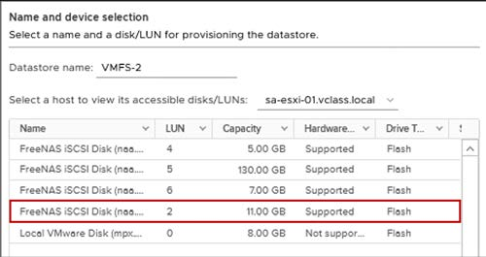
- In the navigation pane, right-click ICM-Datacenter and select Storage > New Datastore. ==> The New Datastore wizard opens.
- On the Type page, verify that VMFS is selected and click NEXT.
- On the Name and device selection page, enter VMFS-2 in the Datastore name text box.
- From the Select a host to view its accessible disks/LUNs drop-down menu, select sa-esxi-01.vclass.local. ==> A LUN list appears.
- In the LUN list, select LUN 2 (11 GB in size).
- Click NEXT.
- On the VMFS version page, accept VMFS 6 and click NEXT.
- On the Partition configuration page, move the Datastore Size slider to reduce the datastore size by 3 GB and click NEXT. ==> For example, if the datastore size is 11 GB, change the size to 8 GB.
- On the Ready to complete page, review the information and click FINISH.
4. In the navigation pane, verify that the VMFS-2 datastore appears under ICM-Datacenter.
5. In the navigation pane, select VMFS-2.
6. In the right pane, select the Summary tab and record the value for storage capacity.
_ _ _ _ _ _ _ _ _ _
7. Create a VMFS datastore called VMFS-3 on the specified LUN on sa-esxi-02.vclass.local.
- Right-click ICM-Datacenter and select Storage > New Datastore.
- On the Type page, verify that VMFS is selected and click NEXT.
- On the Name and device selection page, enter VMFS-3 in the Datastore name text box.
- From the Select a host to view its accessible disks/LUNs drop-down menu, select sa-esxi-02.vclass.local. ==> A LUN list appears.
- In the LUN list, select LUN 6 (7 GB in size) and click NEXT.
- On the VMFS version page, accept VMFS 6 and click NEXT.
- On the Partition configuration page, accept the default (Use all available partitions) and click NEXT.
- On the Ready to complete page, review the information and click FINISH.
8. Verify that the VMFS-3 datastore appears under ICM-Datacenter.

